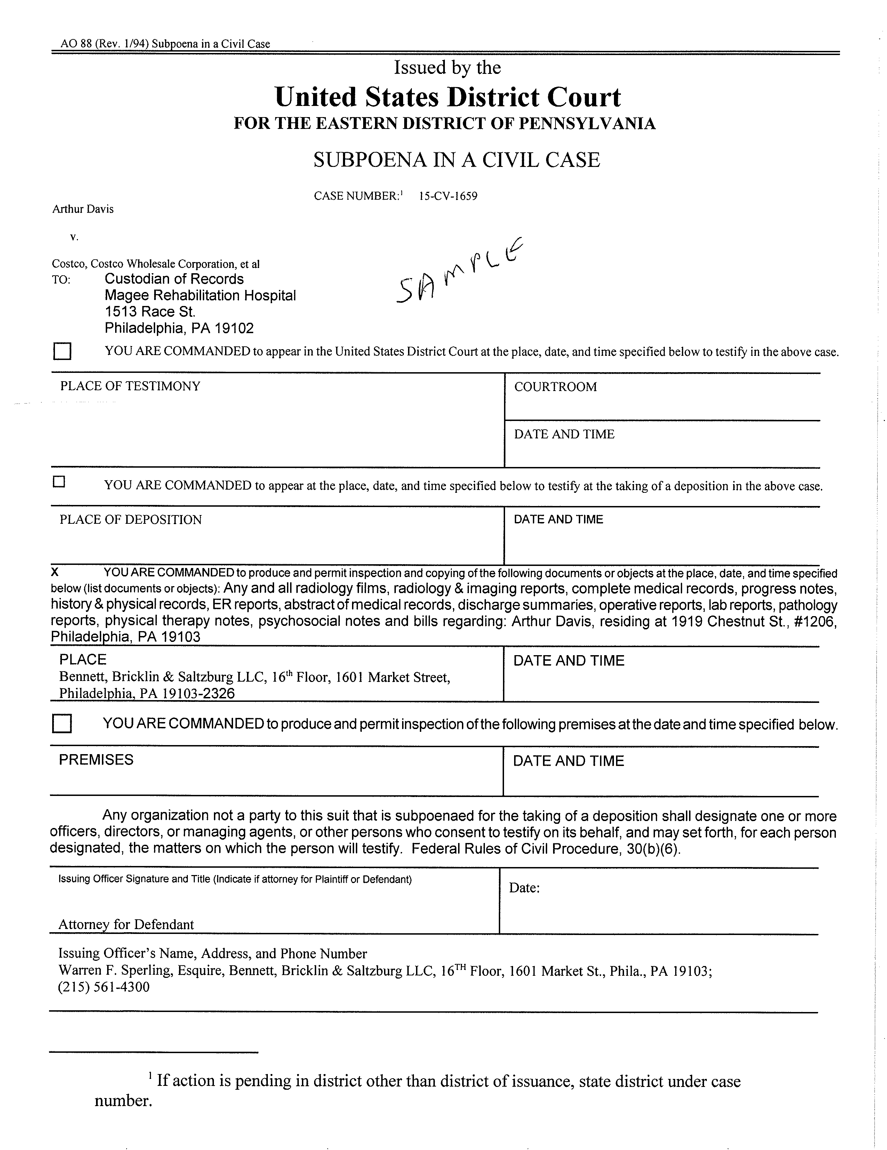

April Term 2015 01810
KYLE WASHINGTON and JEAN-RENEL MARQUIS,

vs.

ANTHONY CROCETTO a/k/a ANTHONY CROCELTO,
Custodian of records
Safe Auto Insurance Company
4 Easton Oval
Columbus, OH 43219-0000
Any and all INSURANCE RECORDS (DOA 9/23/13, claim #644008, policy #PA931939) pertaining to Kyle Washington a/k/a Tilet Washington SSN: , DOB: 06/24/1969, including but not limited to declaration pages and endorsements, investigation material, correspondence, notes, witness statements, videotapes, photographs, medical bills, medical records and all other information pertaining to the claimant.
Maureen O’Connor
FOR THE DISTRICT OF Pennsylvania

The Office of the Custodian: 4 Easton Oval
Columbus, OH 43219-0000

Maureen O’Connor
c/o Axiom Requisition Copy Service
2869 Jolly Road Okemos, MI 48864 (877) 886-5090
Order No. 01-35503-001
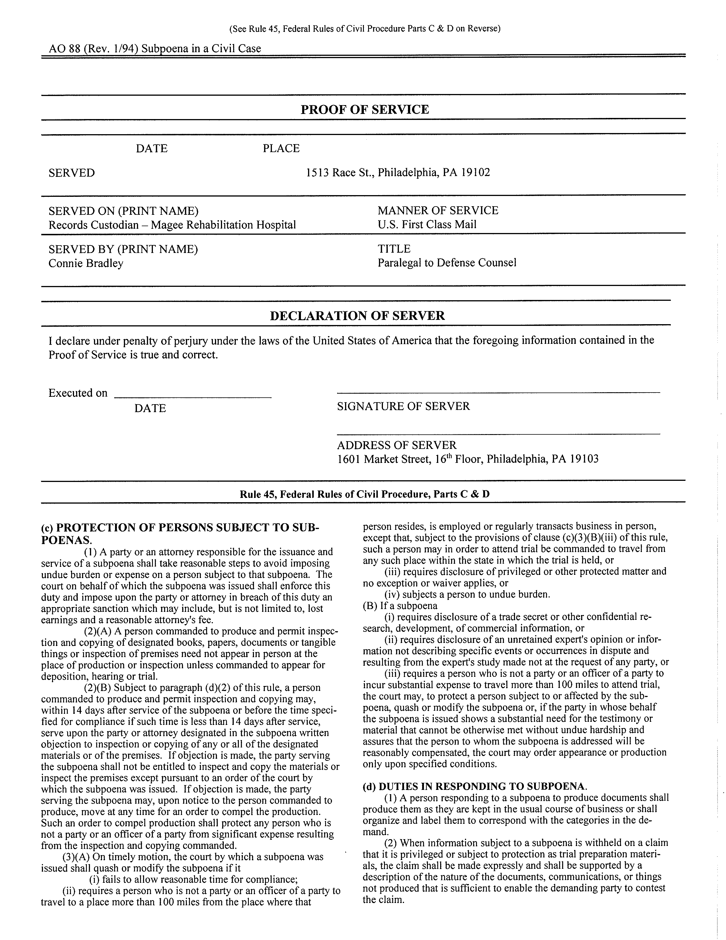
4 Easton Oval Columbus, OH 43219-0000
Custodian of records - Safe Auto Insurance Company

CEO
Josh Sanford
2869 Jolly Road Okemos, MI 48864 (877) 886-5090

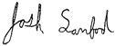
Order No. 01-35503-001
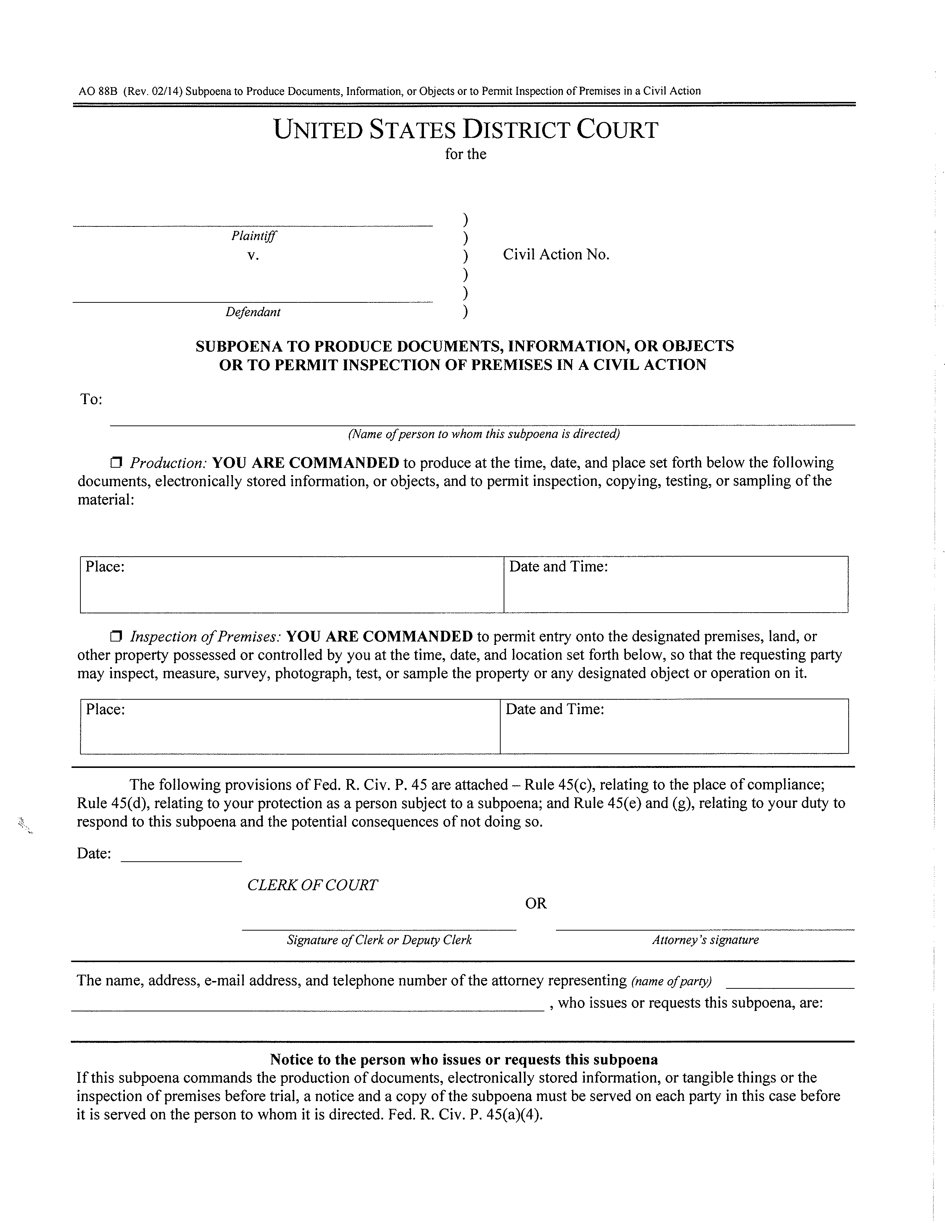
KYLE WASHINGTON and JEAN-RENEL MARQUIS,
ANTHONY CROCETTO a/k/a ANTHONY CROCELTO,
April Term 2015 01810
Safe Auto Insurance Company
4 Easton Oval Columbus, OH 43219-0000
X
Any and all INSURANCE RECORDS (DOA 9/23/13, claim #644008, policy #PA931939) pertaining to Kyle Washington a/k/a Tilet Washington SSN: , DOB: 06/24/1969, including but not limited to declaration pages and endorsements, investigation material, correspondence, notes, witness statements, videotapes, photographs, medical bills, medical records and all other information pertaining to the claimant.
Axiom Requisition Copy Service
2869 Jolly Road
Okemos, MI 48864 PH: (877) 886-5090
at 9:00 am
Anthony Crocetto
Maureen O’Connor - Lucas and Cavalier, LCC 1500 Walnut StreetSuite 1500 Philadelphia, PA 19102-0000 (215) 751-9192
FOR THE DISTRICT OF Pennsylvania
Order No. 01-35503-001
Maureen O’Connor

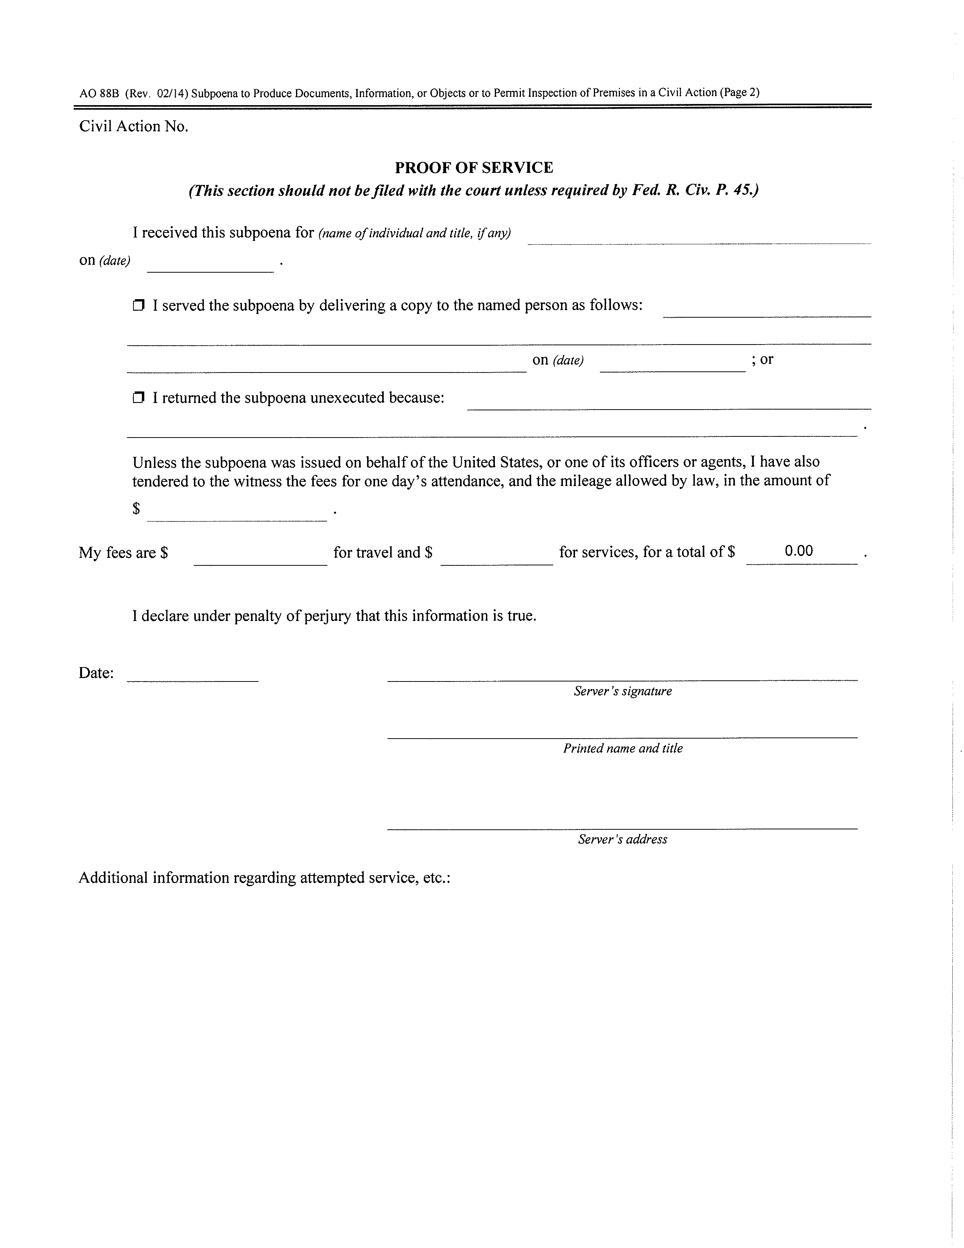
April Term 2015 01810
Order No. 01-35503-001
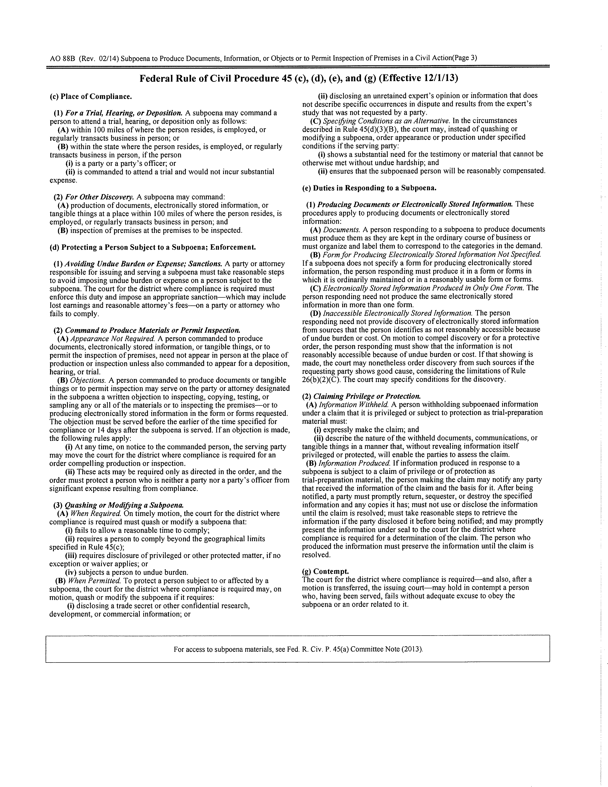
Order No. 01-35503-001

